Cross-quantilogram: USDCAD and EURGBP
Method 20 / daily log returns / expanding quantiles / Alpari D1 full available history

Study setup
Logical pair: USDCAD , EURGBP
Broker symbols: USDCAD_i , EURGBP_i
Snapshot: 2026-11-03_majors_alpari_D1
Timeframe: D1
Matched return window: 1999-01-06 to 2026-11-02 (UTC bar dates)
Matched return count n: 7185
Dropped unfinished last bar dated 2026-11-03 UTC after a tick-volume check against the prior complete day.
Quantiles: expanding window, min history 252 days
tau in [0.05, 0.2]; k=0..10; headline tau=0.05, k=1
Complete matched rows (Excel): USDCAD-EURGBP_CQ_D1.xlsx
Complete matched rows (HTML table): USDCAD-EURGBP_CQ_D1_data.html

Method carried forward
The cross-quantilogram rho_tau(k) measures linkage among centered quantile-hit indicators of matched daily log returns of close, ln(close_t / close_t-1). Quotes are not inverted. At each date t, the tau-quantile uses only returns through t (expanding window) after a minimum history of 252 days. Hits are h_t = 1(r_t < q_t) - tau. rho_tau(k) is the normalized cross-product of h_x,t with h_y,t+k. Levels tau in {0.05, 0.20} and lags k=0..10 are pre-specified; headline is tau=0.05, k=1 both directions. Same-sample Pearson r is a side check. This is not causation and not a trading signal.

Results (headline)
rho_USDCAD->EURGBP(tau=0.05,k=1): 0.056515
rho_EURGBP->USDCAD(tau=0.05,k=1): 0.036370
rho_USDCAD->EURGBP(tau=0.20,k=1): 0.037333
rho_EURGBP->USDCAD(tau=0.20,k=1): 0.029619
Pearson r: -0.014622

CQ table (tau=0.05)
k | rho_USDCAD_to_EURGBP | n_USDCAD_to_EURGBP | rho_EURGBP_to_USDCAD | n_EURGBP_to_USDCAD
0 | 0.00951833 | 6934 | 0.00951833 | 6934
1 | 0.05651453 | 6933 | 0.03636974 | 6933
2 | 0.02964667 | 6932 | 0.00950171 | 6932
3 | 0.026281 | 6931 | 0.01956596 | 6931
4 | 0.05313324 | 6930 | 0.00948508 | 6930
5 | -0.00059597 | 6929 | 0.01619192 | 6929
6 | 0.01954127 | 6928 | 0.02625649 | 6928
7 | 0.03967886 | 6927 | 0.02960595 | 6927
8 | 0.02624015 | 6926 | -0.00062117 | 6926
9 | 0.02287428 | 6925 | 0.02958967 | 6925
10 | 0.03629697 | 6924 | 0.01950836 | 6924

Conclusion
Headline tau=0.05, k=1 for USDCAD and EURGBP: rho_USDCAD->EURGBP = 0.0565; rho_EURGBP->USDCAD = 0.0364. At tau=0.20, k=1: 0.0373 and 0.0296. Same-day tau=0.05 rho(k=0) = 0.0095. Pearson r = -0.0146. This is quantile-hit linkage, not a trading signal.

Charts
Daily closes

Daily log returns

Cross-quantilogram tau=0.05
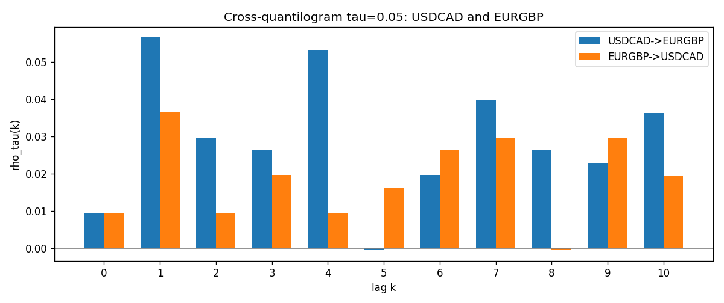

Data report
Matched rows and the CQ sheet are in the sibling Excel workbook named USDCAD-EURGBP_CQ_D1.xlsx. Embedding all rows as a Word table is impractical; this file holds column summaries and the first and last 15 matched rows.
Columns: time, USDCAD_open, EURGBP_open, USDCAD_high, EURGBP_high, USDCAD_low, EURGBP_low, USDCAD_close, EURGBP_close, USDCAD_tick_volume, EURGBP_tick_volume, USDCAD_spread, EURGBP_spread, USDCAD_real_volume, EURGBP_real_volume, USDCAD_log_return, EURGBP_log_return, USDCAD_h_t005, EURGBP_h_t005
Column summaries (matched calculation rows)
column | count | mean | std | min | 25% | 50% | 75% | max
USDCAD_open | 7185 | 1.2666594 | 0.16886861 | 0.9168 | 1.1183 | 1.29841 | 1.37203 | 1.6183
EURGBP_open | 7185 | 0.78693389 | 0.09666561 | 0.5734 | 0.6876 | 0.83387 | 0.86521 | 0.9769
USDCAD_high | 7185 | 1.2715589 | 0.16882635 | 0.9336 | 1.1227 | 1.30381 | 1.3764 | 1.619
EURGBP_high | 7185 | 0.79000929 | 0.09704455 | 0.5789 | 0.6896 | 0.8369 | 0.8681 | 0.9799
USDCAD_low | 7185 | 1.2621046 | 0.16891061 | 0.9056 | 1.11396 | 1.29347 | 1.36776 | 1.6102
EURGBP_low | 7185 | 0.78423344 | 0.09648411 | 0.5682 | 0.6855 | 0.83166 | 0.86287 | 0.9661
USDCAD_close | 7185 | 1.2666836 | 0.16885076 | 0.916 | 1.118 | 1.29833 | 1.3723 | 1.6137
EURGBP_close | 7185 | 0.78697576 | 0.09666885 | 0.5735 | 0.6878 | 0.83391 | 0.86533 | 0.977
USDCAD_tick_volume | 7185 | 81049.359 | 147325.09 | 37 | 5563 | 40946 | 71633 | 1410818
EURGBP_tick_volume | 7185 | 87109.869 | 145486.28 | 154 | 6553 | 44326 | 81375 | 1424684
USDCAD_spread | 7185 | 23.430202 | 18.259258 | 0 | 9 | 17 | 40 | 60
EURGBP_spread | 7185 | 21.335421 | 19.123862 | 0 | 4 | 13 | 40 | 50
USDCAD_real_volume | 7185 | 1.8384377e+10 | 9.670755e+10 | 0 | 0 | 0 | 0 | 2.5751613e+12
EURGBP_real_volume | 7185 | 2.7864528e+10 | 1.3519652e+11 | 0 | 0 | 0 | 0 | 3.5726265e+12
USDCAD_log_return | 7185 | -8.08e-06 | 0.00514591 | -0.03859748 | -0.00283484 | 5.597e-05 | 0.00272835 | 0.03436319
EURGBP_log_return | 7185 | 1.874e-05 | 0.00486681 | -0.03067367 | -0.00262366 | -0.00010035 | 0.00255918 | 0.06075387
USDCAD_h_t005 | 6934 | 0.00220652 | 0.22245929 | -0.05 | -0.05 | -0.05 | -0.05 | 0.95
EURGBP_h_t005 | 6934 | -0.01134987 | 0.19277359 | -0.05 | -0.05 | -0.05 | -0.05 | 0.95
First 15 matched rows (selected columns)
time | USDCAD_log_return | EURGBP_log_return | USDCAD_h_t005 | EURGBP_h_t005
1999-01-06 | -0.0003306769 | -0.013303338 | nan | nan
1999-01-07 | 0.0015202092 | 0.011051402 | nan | nan
1999-01-08 | -0.0020495197 | -0.004943862 | nan | nan
1999-01-11 | -0.0035137769 | -0.0012752393 | nan | nan
1999-01-12 | 0.0066194721 | 0.0033970309 | nan | nan
1999-01-13 | 0.0045420214 | 0.00042381861 | nan | nan
1999-01-14 | 0.0069376546 | -0.0019793588 | nan | nan
1999-01-15 | -0.0056905671 | -0.0076715819 | nan | nan
1999-01-18 | 0.00098344542 | 0.00071280921 | nan | nan
1999-01-19 | 0.002748513 | -0.0014261269 | nan | nan
1999-01-20 | -0.0059646885 | 0.0019960086 | nan | nan
1999-01-21 | -0.0042823796 | -0.00071240297 | nan | nan
1999-01-22 | 0.0025057712 | -0.0017118406 | nan | nan
1999-01-25 | 0.00085579808 | -0.0054402425 | nan | nan
1999-01-26 | 0.0001973879 | -0.00057438255 | nan | nan
Last 15 matched rows (selected columns)
time | USDCAD_log_return | EURGBP_log_return | USDCAD_h_t005 | EURGBP_h_t005
2026-10-13 | -0.0046395653 | 0.00020130374 | -0.05 | -0.05
2026-10-14 | 0.0015184751 | 0.0011241873 | -0.05 | -0.05
2026-10-15 | -0.0036101503 | -0.00087557391 | -0.05 | -0.05
2026-10-16 | -0.0034322068 | -0.0020380844 | -0.05 | -0.05
2026-10-19 | -0.0018835331 | -0.00056950988 | -0.05 | -0.05
2026-10-20 | -0.0037066008 | -0.0035906254 | -0.05 | -0.05
2026-10-21 | -0.00084691787 | -0.00140647 | -0.05 | -0.05
2026-10-22 | -0.0026307268 | -0.0018743924 | -0.05 | -0.05
2026-10-23 | 2.85545e-05 | 0.00082421033 | -0.05 | -0.05
2026-10-26 | 5.7106554e-05 | 0.00013133309 | -0.05 | -0.05
2026-10-27 | 0.0025379458 | -0.0019957343 | -0.05 | -0.05
2026-10-28 | -0.0038379274 | 0.00066967224 | -0.05 | -0.05
2026-10-29 | -0.00011436495 | -0.0011722209 | -0.05 | -0.05
2026-10-30 | -0.0010298736 | -0.0024205543 | -0.05 | -0.05
2026-11-02 | 0.00061519094 | 0.00089940465 | -0.05 | -0.05

